**DOCUMENT CREATION USING VOICE TYPING  
CS8611 – Mini Project**

**A PROJECT REPORT**

***Submitted by***

***S.VIGNESHRAJ (813817104107)***

***in partial fulfillment for the award of the degree***

***of***

**BACHELOR OF ENGINEERING**

**in**

**COMPUTER SCIENCE AND ENGINEERING**



**SARANATHAN COLLEGE OF ENGINEERING, TRICHY**



**ANNA UNIVERSITY : CHENNAI 600 025**

**APRIL 2020**

**ANNA UNIVERSITY : CHENNAI 600 025**

**BONAFIDE CERTIFICATE**

Certified that this project report **“DOCUMENT CREATION USING VOICE TYPING”** is the bonafide work of

|  |  |
| --- | --- |
| **VIGNESHRAJ .S** | **813817104107** |

who carried out the mini-project work (CS8611) under my supervision.

SIGNATURE SIGNATURE

**Dr. S.A. Sahaaya Arul Mary, M.E., Ph.D Mr. K.S. Chandrasekaran, M.E.,**

HEAD OF THE DEPARTMENT ASSOCIATE PROFESSOR

Computer Science and Engineering, Computer Science and Engineering,

Saranathan College of Engineering, Saranathan College of Engineering,

Panjapur, Panjapur,

Tiruchirapalli-620 012 Tiruchirapalli-620 012

**VIVA - VOCE EXAMINATION**

**DOCUMENT CREATION USING VOICE TYPING**

*Submitted by*

|  |  |
| --- | --- |
| **VIGNESHRAJ.S** | **813817104107** |

The Viva - Voce Examination of this Mini-Project (CS8611) work done as a part of B.E. Computer Science and Engineering was held on ___________.

|  |  |
| --- | --- |
| **INTERNAL EXAMINER** | **EXTERNAL EXAMINER** |

**ACKNOWLEDGEMENT**

“Thanks” is a simple word but its eloquence is magnified when it comes from the depth of the heart. I take this opportunity to thank all the encouragers and supporters of this project.

First and foremost I thank the Almighty who has been an unfailing source of strength and comfort for showering his blessing throughout this study.

I sincerely thank our beloved secretary **Shri.S.Ravindran** and energetic principal **Dr.D.Valavan, M.Tech., Ph.D.,** for providing all the necessary facilities to do the project work successfully.

I take this opportunity to extend my deep sense of gratitude to thank, **Dr.S.A.Sahaaya Arul Mary, M.E., Ph.D**, Head of the Department, Computer Science and Engineering for supporting me throughout the venture.

I wish to acknowledge our sincere gratitude and indebtedness to our project wok in-charges **Mr.K.S.Chandrasekaran, M.E.,** and **Mr.R.Mohankumar, M.E.,** for their inspiring guidance, motivation encouragement and help rendered me throughout the project for its successful completion.

I am thankful to all staff members of Computer Science and Engineering, Saranathan College of Engineering for their valuable comments during the project implementation. A hearty thanks to non-teaching staff of Computer Science and Engineering who provided the necessary facilities to complete the project. Also I am thankful to my parents and friends who have been so encouraging and supporting me morally and helping in time of despair.

**SARANATHAN COLLEGE OF ENGINEERING**

**Venkateswara Nagar, Panjappur, Tiruchirapalli-620012**

|  |
| --- |
| **VISION OF THE INSTITUTION**  Impart an inclusive engineering education that beyond being a facilitator for a career and rudimentary skills, equips the students to offer ethically & environmentally conscious solutions to societal issues. |

|  |
| --- |
| **MISSION OF THE INSTITUTION**  Develop the Institution into a Model Self Financing College for Engineering and Technology. Deliver Professional Training to our students with state-of-the art laboratories and converting them into Technocrats of international repute.   1. Create a nurturing, holistic environment of engineering education to facilitate every student realize their full potential. 2. Strive to make the students strong in basic concepts armed with appropriate skills to enhance one’s ability to apply the knowledge to provide solutions to real time issues. 3. Maintain an ambience that facilitates the students to strengthen their ethical value systems. 4. Actively promote R&D and institute-industry interaction. |

|  |
| --- |
| **VISION OF THE DEPARTMENT**  To evolve as a centre of academic excellence and advanced research in Computer Science and Engineering discipline. |

|  |
| --- |
| **MISSION OF THE DEPARTMENT**   1. To inculcate in students a profound understanding of fundamentals related to discipline. 2. To inculcate skills, attitudes and their applications in solving real world problems with an inclination towards societal issues and research. 3. To promote research in the emerging areas of computer science and technology |

|  |
| --- |
| **PROGRAM EDUCATIONAL OBJECTIVES (PEOS)**  **PEO1**: Acquire strong foundation in the mathematical, scientific and engineering fundamentals necessary to formulate, solve and analyze engineering problems.  **PEO2**: Develop the ability to analyze the requirements of the software, understand the technical specifications, design and provide novel engineering solutions and efficient software/hardware designs.  **PEO3**: Have exposure to emerging cutting edge technologies, adequate training & opportunities to work as teams on multidisciplinary projects with effective communication skills and leadership qualities.  **PEO4**: Have awareness on the life-long learning and prepare them for research development and consultancy.  **PEO5:** Have a successful career and work with values & social concern bridging the digital  divide and meet the requirements of Indian and multinational companies. |

|  |
| --- |
| **PROGRAM SPECIFIC OUTCOME (PSO)**     1. **PS01**: Foundation of mathematical concepts: To use mathematical methodologies to crack problem using suitable mathematical analysis, data structure and suitable algorithm. 2. **PSO2**: Foundation of Computer System: the ability to interpret the fundamental concepts and methodology of computer systems. Students can understand the functionality of hardware and software aspects of computer systems. 3. **PSO3**: Foundations of Software development: the ability to grasp the software development lifecycle and methodologies of software systems. Possess competent skills and knowledge of software design process. Familiarity and practical proficiency with a broad area of programming concepts and provide new ideas and innovations towards research. |

**Program Outcomes: (POs)**

|  |  |
| --- | --- |
| **PO** | **Program Outcomes** |
| **1** | **PO1: Engineering knowledge**  Apply the knowledge of mathematics, science, engineering fundamentals, and engineering specialization to the solution of complex engineering problems. |
| **2** | **PO2: Problem Analysis**  Identify, formulate, review research literature, and analyze complex engineering problems reaching substantiated conclusions using first principles of mathematics, natural sciences, and engineering sciences. |
| **3** | **PO3: Design/development of solutions**  Design solutions for complex engineering problems and design system components or processes that meet the specified needs with appropriate consideration for the public health and safety, and the cultural, societal, and environmental considerations. |
| **4** | **PO4: Conduct Investigations of Complex Problems**  Use research-based knowledge and research methods including design of exercises, analysis and interpretation of data, and synthesis of the information to provide valid conclusions. |
| **5** | **PO5: Modern Tool Usage**  Create, select, and apply appropriate techniques, resources, and modern engineering and IT tools including prediction and modeling to complex engineering activities with an understanding of the limitations. |
| **6** | **PO6: The Engineer and Society**  Apply reasoning informed by the contextual knowledge to assess societal, health, safety, legal and cultural issues and the consequent responsibilities relevant to the professional engineering practice. |
| **7** | **PO7: Environment and sustainability**  Understand the impact of the professional engineering solutions in societal and environmental contexts, and demonstrate the knowledge of, and need for sustainable development. |
| **8** | **PO8 : Ethics**  Apply ethical principles and commit to professional ethics and responsibilities and norms of the engineering practice. |
| **9** | **PO9: Individual and Team Work**  Function effectively as an individual, and as a member or leader in diverse teams, and in multidisciplinary settings. |
| **10** | **PO10 : Communication**  Communicate effectively on complex engineering activities with the engineering community and with society at large, communication such as, being able to comprehend and write effective reports and design documentation, make effective presentations, and give and receive clear instructions. |

|  |  |
| --- | --- |
| **11** | **PO11: Project management and finance**  Demonstrate knowledge and understanding of the engineering and management principles and apply these to one’s own work, as a member and leader in a team, to manage projects and in multidisciplinary environments. |
| **12** | **PO12: Life-long learning**  Recognize the need for, and have the preparation n and ability to engage in independent and life-long learning in the broadest context of technological change |

**NBA Code for the Subject: C319 Subject Code: CS8611**

**Title: MINI PROJECT**

**COURSE OUTCOMES:** At the end of this course, Student will be able to

|  |  |
| --- | --- |
| **Course Code** | **Course outcome Description** |
| **C319.1** | Gather and interpret technical literature to formulate a project proposal to solve challenging practical problems. |
| **C319.2** | Identify SDLC model and prepare software requirements specification. |
| **C319.3** | Design the software architecture. |
| **C319.4** | Apply modern tools for implementation using best coding practices and.testing at various levels of the project. |
| **C319.5** | Document the technical report on identified topic and present the ideas with effective communication skills |
| **C319.6** | Learn the concepts of project management and to work effectively as a member in team. |

|  |  |  |  |  |  |  |  |  |  |  |  |  |  |  |  |
| --- | --- | --- | --- | --- | --- | --- | --- | --- | --- | --- | --- | --- | --- | --- | --- |
|  | **SUBJECT CODE : CS8611 NBA CODE : C319 TITLE : MINI PROJECT** | | | | | | | | | | | | |  |  |
| **Course Code** | **PO1** | **PO2** | **PO3** | **PO4** | **PO5** | **PO6** | **PO7** | **PO8** | **PO9** | **PO10** | **PO11** | **PO12** | **PSO1** | **PSO2** | **PSO3** |
| **C319.1** | **2** | **2** | **2** | **2** | **2** | **2** | **-** | **1** | **2** | **2** | **2** | **2** | **2** | **2** | **2** |
| **C319.2** | **2** | **2** | **2** | **2** | **2** | **2** | **-** | **1** | **2** | **2** | **2** | **2** | **2** | **2** | **2** |
| **C319.3** | **2** | **2** | **2** | **2** | **2** | **2** | **-** | **1** | **2** | **2** | **2** | **2** | **2** | **2** | **2** |
| **C319.4** | **2** | **2** | **2** | **2** | **2** | **2** | **-** | **1** | **2** | **2** | **2** | **2** | **2** | **2** | **2** |
| **C319.5** | **2** | **2** | **2** | **2** | **2** | **2** | **-** | **1** | **2** | **2** | **2** | **2** | **2** | **2** | **2** |
| **C319.6** | **2** | **2** | **2** | **2** | **2** | **2** | **-** | **1** | **2** | **2** | **2** | **2** | **2** | **2** | **2** |

**DOCUMENT CREATION BY VOICE TYPING**

**ABSTRACT**

Many people are in need of working with or creating word document. Writing large number of lines and paragraphs on word documents is tiring work. Many look for others' help or Computer centre help in order to type. Creating such a huge word document takes hours to complete. Same in the case of creating an excel document. So, this proposed application is intended to be make things easier in creation of document. With respect to the above problem, this application makes creating documents in an easier way. This application enables people to create documents by voice. It would be easy for them. It gives the voice driven document creation. So, people can just read out their content that is to be included in the word document. The user no need to touch the keyboard and can save the file from this application. Working in Excel document or spreadsheet is even more difficult compared to word document. Moving the cursor to each cell for entering the data is quite a tiring work to do which can be resolved by this proposed system. Same voice recognition is used in this application to create excel document. Thus using this application doesn’t limit the user to include image into document. This application allows the user to include the image by specifying the image location or browsing the location.

This application also comes with the feature of reading the document file in voice which is called as dictate feature. The user can also read the word document from this application. The application will read out the document paragraph by paragraph. Thus, the application’s main motive is to make typing easier in the word and also in excel document creation. The advantage of using speech recognition in order to create document is not only easier for user but also it ensure from the possible typographical errors.

**INTRODUCTION**

Application software (app for short) is a program or group of programs designed for end users. Examples of an application include a [word processor](https://en.wikipedia.org/wiki/Word_processor), a [spreadsheet](https://en.wikipedia.org/wiki/Spreadsheet), an [accounting application](https://en.wikipedia.org/wiki/Accounting_software), a [web browser](https://en.wikipedia.org/wiki/Web_browser), an [email client](https://en.wikipedia.org/wiki/Email_client), a [media player](https://en.wikipedia.org/wiki/Media_player_(software)), a [file viewer](https://en.wikipedia.org/wiki/File_viewer), an aeronautical [flight simulator](https://en.wikipedia.org/wiki/Flight_simulator), a [console game](https://en.wikipedia.org/wiki/Console_game) or a [photo editor](https://en.wikipedia.org/wiki/Raster_graphics_editor). The [collective noun](https://en.wikipedia.org/wiki/Collective_noun) application software refers to all applications collectively. Applications may be [bundled](https://en.wikipedia.org/wiki/Product_bundling) with the computer and its system software or published separately, and may be coded as [proprietary](https://en.wikipedia.org/wiki/Proprietary_software), [open-source](https://en.wikipedia.org/wiki/Open-source_model) or university projects.

There are many software packages to do the job of word processing. Some of them work in DOS environment. Example are WordStar, Word Perfect and Professional Write. But in these days working in windows is becoming more and more popular. MS-WORD is a part of the bigger package called MS OFFICE, which can do much more than word processing.

Microsoft Excel is a spreadsheet program that is used to record and analyse numerical data. Think of a spreadsheet as a collection of columns and rows that form a table. Alphabetical letters are usually assigned to columns and numbers are usually assigned to rows. The point where a column and a row meet is called a cell. The address of a cell is given by the letter representing the column and the number representing a row.

Creating documentation is wide used process for many professionals. They sometime needs to create vast number of pages in word documents. Typing such huge numbers of lines can be reduced by the proposed application.

This proposal suggest the creation of document via speaking the content of material. This application has interface where the user can specify the name of the document. This application also works in online, but it doesn’t need greater bandwidth to work. Thus, this documentation explains the whole features and importance of this application. The advantage of this proposed system are as follows

* Free from any typo errors.
* Reduces man effort in typing.
* Both excel and word creation in one application

**EXSITING SYSTEMS**

The existing system are various word documents editors such as MS office, Liber, etc. In which there is no voice typing option rather user have to typing manually using keyboard. But, there is also other few options available regarding to the problem such as windows speech recogniser which is available in Operating System and these features are less known to the people. In addition to that there is also google docs which has the voice typing tools which works online. But, it doesn’t have dictate option in it.

**THE APPLICATION WORKS AS FOLLOWS**

When the user downloaded and installed the application. The user are given various menu regarding this application. Once the user clicked the start word document creation button, the user is navigated to the next interface of application. When the user is clicks the voice typing button the user is allowed to start speaking the content to be included.

Along with that the user can also navigate through the menus of this application with the help of voice command. It is difficult if the user have to switch to old application in order to include an image. So, the application has a provision to include the image into document.

Next feature comes in the application is reading the document. The address location of document that is to be read is given. The reads the line by line of the document in speech formats.

**PROPOSED SYSTEM**

The purpose of this application is to simplify the typing effort of the word document creator by voice typing. Though there is voice typing option available in the google docs which works on online. There is also Windows Speech Recognition feature in Windows Operating System. All these features are less known among the people. But, this proposed system brings the voice typing feature and dictate feature into a single application. People can now do their document work without putting much effort. The proposed system also helps to read the document in an efficient manner. The application helps to read out in a voice. This makes user to read out some document without putting much effort. Also the proposed has provision to include the image into the document.

**SYSTEM ARCHITECTURE**

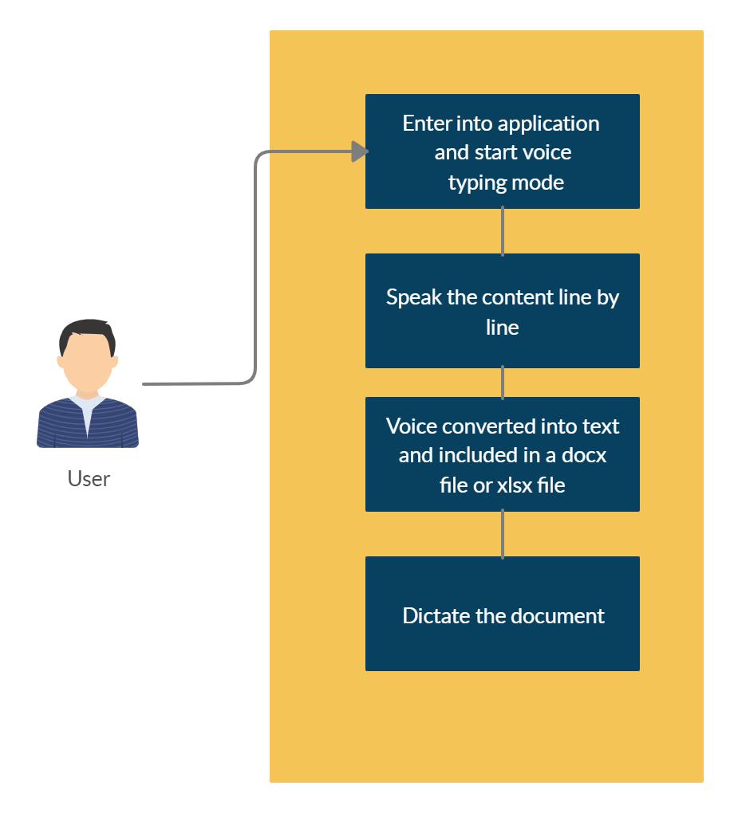

**FLOW**

As shown in Fig. the user first starts the voice typing mode in the application. Then, after the contents are spoken and inserted in to a document, the document is saved. If the user wishes to read the document. The dictate option can be used.

**USE CASE DIAGRAM**

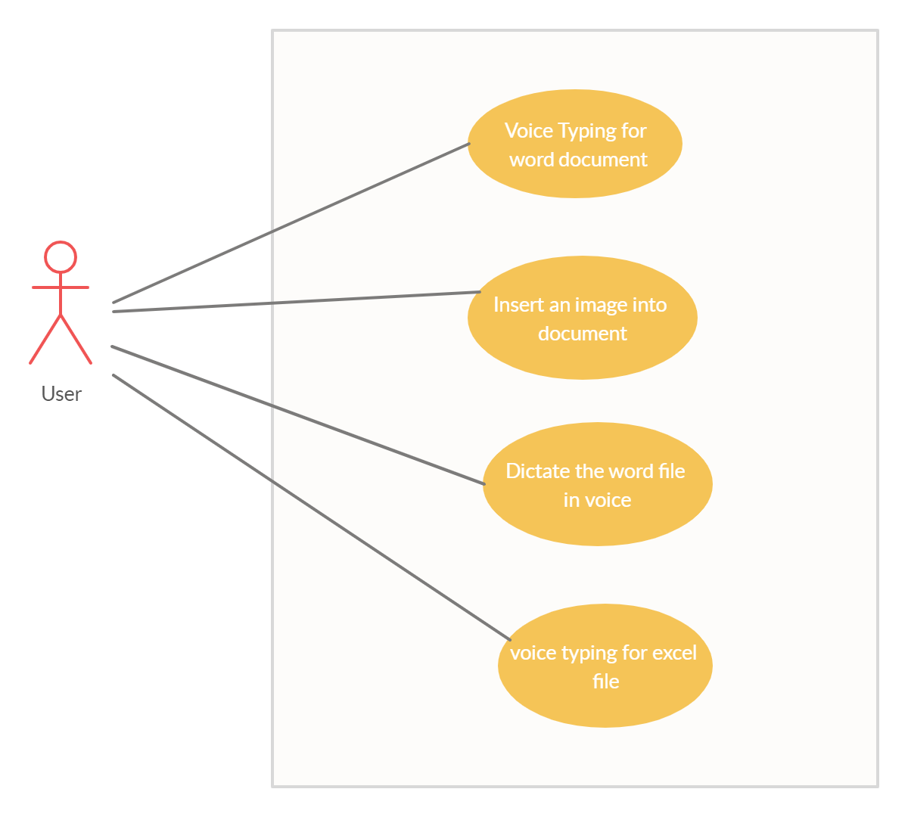

**REQUIREMENTS**

**FUNCTIONAL REQUIREMENTS**

* The application needs the voice to be undisturbed that is without any sort of noises.
* It needs the sentences to be included in line by line manner only.
* Long pause or full stop marks the end of a line.

**SYSTEM REQUIREMENTS**

A python application can ideally be developed on any platform.

* Windows
* Linux

**SOFTWARE REQUIREMENTS**

* Python idle
* Python packages

**HARDWARE REQUIREMENTS**

* RAM: 1GB or more memory
* Microphone is most preferred.

**MODULE EXPLANATION**

**MENU PAGE**

The first page of this application is the menu page where you are given three options to select from voice typing for word document, dictate option or voice typing for excel document. The entire application is built by using tkinter package present in the python language.

**VOICE TYPING FOR WORD DOCUMENT:**

In order to work with document the docx package is installed and used. When the user clicks the voice typing option in the menu which is displayed on screen. The user starts to speak the content of the document. The voice to text converter in python package will convert the voice into text and display the text in a text box. In this application python package Speech Recognizer is used in order to recognize the text. The user on saying full stop or leaving a long pause will leads to the application writing those sentences into a document. Then, the user need to give the name of the file in which the file has to be save. Once the user is done with the creation of document they can save their document from the application itself.

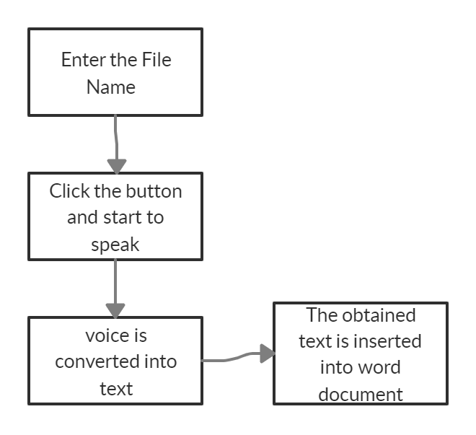

**IMAGE INCLUDE:**

People use simple images in order to illustrate some concept or thing. Using this editor to create the word document doesn’t limit the user to include the image into word document. For including image you don’t need to switch to the default application, this application itself has the option to include image. The user can paste the image location or can use the browse option to find the image. Then, click the insert button in order to include into the document.

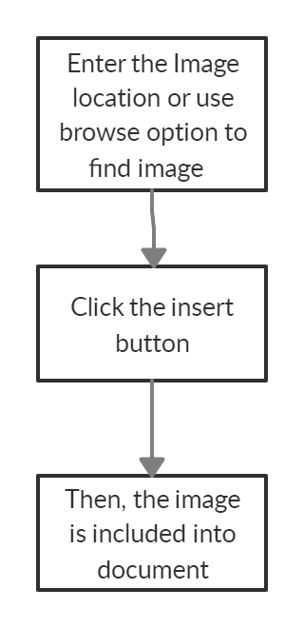

**DICTATE**

Once the user created the document, the user may want to read the document. The user can find the dictate option in the menu page. After entering into the dictate page the user have specify the location of the document or use the browse option to obtain the location of the file. So, the user have tocopy and paste the address of the document. When dictate button is clicked the python speech to text module will convert text in document into speech. The each paragraph in document is converted into speech.

But, the dictate option is only available for word document and not for excel document.

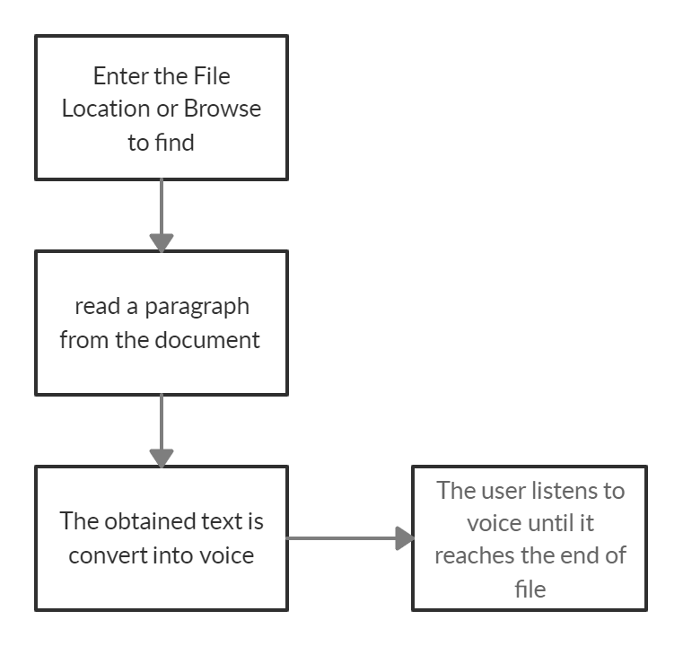

**VOICE TYPING FOR WORD DOCUMENT:**

After selecting the voice typing for excel document option in menu

page. In order to work with the excel document, the xlsxwriter python package

is installed and used. First the user have to specify the file name. Then the user

clicks the listen button. The application begins to listen to the voice. The speech

is converted into text and then, the text is converted into list. The input is

included into the excel document in row wise manner. Then, the document can

be saved.

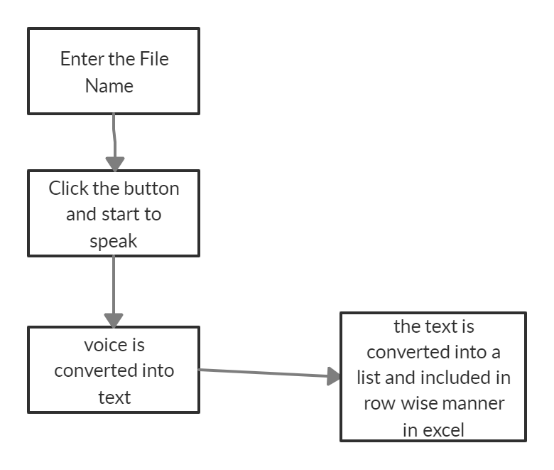

**CONCLUSION:**

The word document and excel document creation is very important in

the life of every employee, students, teacher, etc. It is also a tiring job to do

some large pages document. This application comes with speech recognition to

make things easy between the user and document creation. This application has

user friendly and hands free way to create a document. It helps the user in

various occupation to make us of this application to create the document

simultaneously with an efficient human effort and time.

**SCREENSHOTS:**

1. **Menu Page**

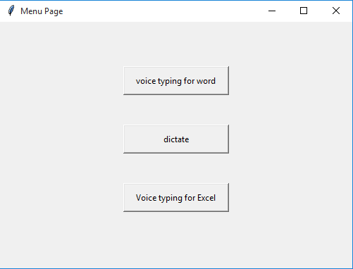

1. **Voice typing page for excel file**

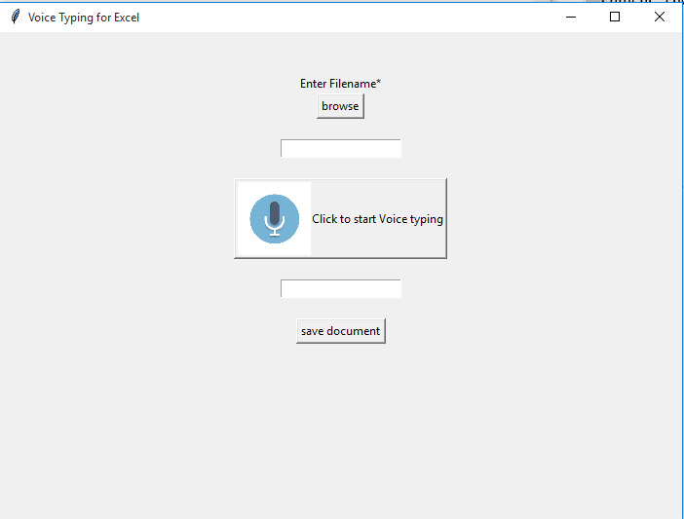

**3. Dictate Page**

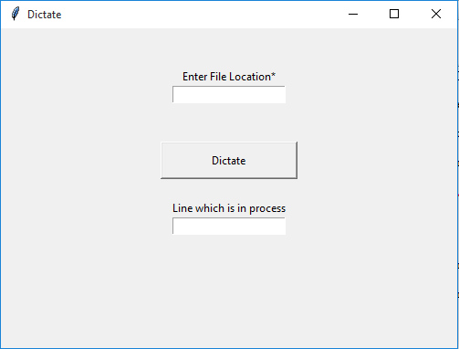

**4. Voice typing page for word file**

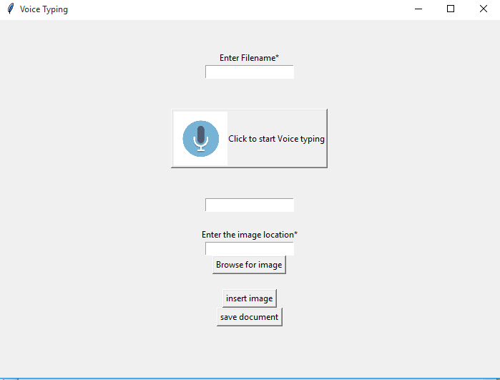

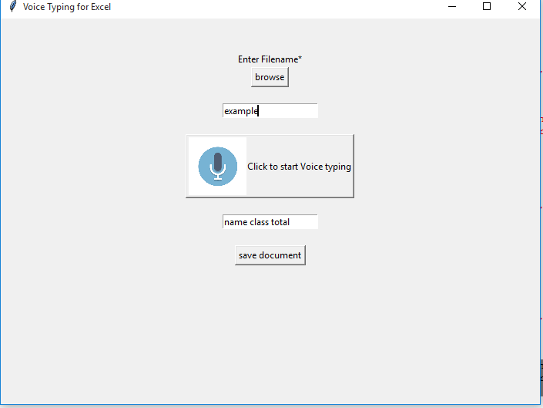 **5. Sample Input for excel creation**

**6. Output for excel file creation  
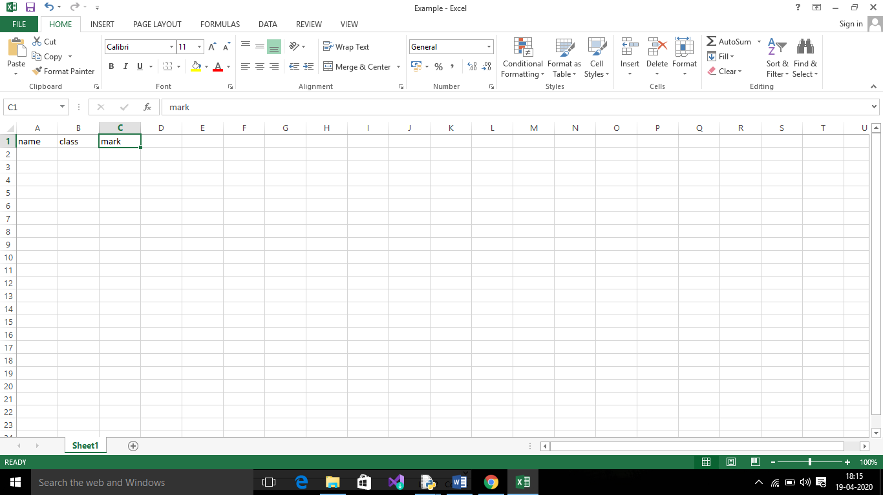**

**7.Input for Word file creation**

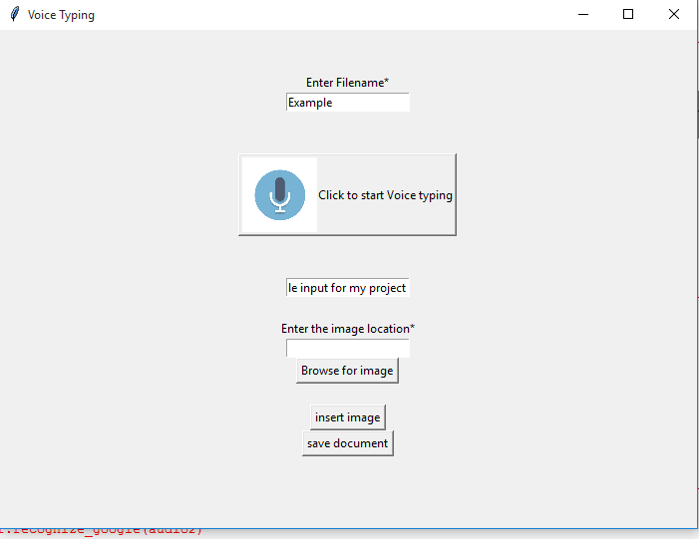

**8. Output for Word file creation**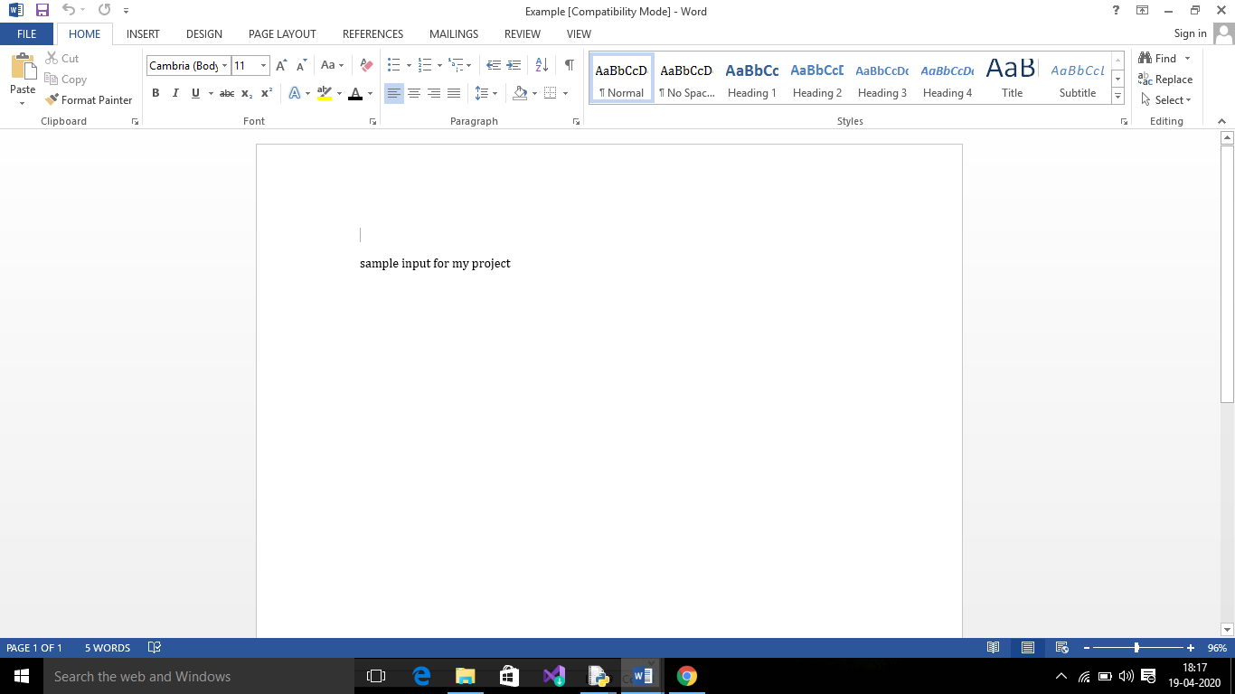

**CODING:**

**MAIN PAGE:**

from tkinter import *

def myWindow():

myWindow=Tk()

myWindow.title("Menu Page")

myWindow.geometry("500x350")

#event listener for voice typing

def voice():

myWindow.destroy()

exec(open('voice.py'.read()))

return

#event listener for dictate option

def dictate():

myWindow.destroy()

exec(open('dictate.py').read())

return

#event listener for excel creation

def excel():

myWindow.destroy()

exec(open('excel.py').read())

Label(myWindow, text="").pack()

Label(myWindow, text="").pack()

Label(myWindow, text="").pack()

#button for voice typing

vc=Button(myWindow, text="voice typing for word", width=20, height=2,command=voice).pack()

Label(myWindow, text="").pack()

Label(myWindow, text="").pack()

#button for dictate

dt=Button(myWindow, text="dictate", width=20, height=2,command=dictate).pack()

Label(myWindow, text="").pack()

Label(myWindow, text="").pack()

#button for excel creation

Button(myWindow, text="Voice typing for Excel", width=20, height=2,command=excel).pack()

myWindow.mainloop()

#calling the tkinter main window

myWindow()

**WORD CREATION BY VOICE TYPING:**

from tkinter import *

import speech_recognition as sr

import pyttsx3

from docx import Document

from docx.shared import Inches

from tkinter import filedialog

#function to browse the loction of address

def browse_button():

filename = filedialog.askdirectory()

print(filename)

global i

i.set(filename)

return

doc = Document()

doc_para = doc.add_paragraph("")

#function to insert image into document

def insert():

global doc

global i

address=i.get()

doc.add_picture(address,width=Inches(1.5))

return

#saving the word document

def save():

global doc

global name

temp= "C:/Users/Hp/Documents/"

string=name.get()

temp=temp+string+".docx"

print(temp)

doc.save(temp)

return

#creating the interface

myWindow=Tk()

myWindow.title("Voice Typing")

myWindow.geometry("700x500")

#function for listening to voice

def listen():

def write(txt):

global doc

doc_para = doc.add_paragraph(txt)

return

# Initialize the recognizer

r = sr.Recognizer()

# Loop infinitely for user to

# speak

while(1):

with sr.Microphone() as source2 :

# wait for a second to let the recognizer

# adjust the energy threshold based on

# the surrounding noise level

r.adjust_for_ambient_noise(source2, duration=0.2)

#listens for the user's input

audio2 = r.listen(source2)

# Using google to recognize audio

MyText = r.recognize_google(audio2)

MyText = MyText.lower()

global s

s.set(MyText)

write(MyText)

Label(myWindow, text="").pack()

Label(myWindow, text="").pack()

Label(myWindow, text="Enter Filename*").pack()

# Creating a photoimage object to use image

photo = PhotoImage(file = r"C:\Users\Hp\Documents\Python Scripts\mic.png")

# Resizing image to fit on button

photoimage = photo.subsample(3, 3)

name=StringVar()

e1 = Entry(myWindow,textvariable=name).pack()

Label(myWindow, text="").pack()

Label(myWindow, text="").pack()

# compound option is used to align image on LEFT side of button

mic=Button(myWindow, text = "Click to start Voice typing", image = photoimage,compound = LEFT,command=listen).pack()

Label(myWindow, text="").pack()

Label(myWindow, text="").pack()

s = StringVar()

e2 = Entry(myWindow,textvariable=s).pack()

Label(myWindow, text="").pack()

Label(myWindow, text="Enter the image location*").pack()

i = StringVar()

Entry(myWindow,textvariable=i).pack()

button2 = Button(text="Browse for image", command=browse_button).pack()

Label(myWindow, text="").pack()

Button(myWindow,text="insert image",command=insert).pack()

#creating the button for save option

Button(myWindow,text="save document",command=save).pack()

myWindow.mainloop()

**EXCEL CREATION USING VOICE TYPING:**

from tkinter import *

import speech_recognition as sr

import pyttsx3

from tkinter import filedialog

import xlsxwriter

def browse_button():

filename = filedialog.askdirectory()

print(filename)

global i

i.set(filename)

return

#saving the excel document

def save():

global workbook

workbook.close()

return

#creating the interface

myWindow=Tk()

myWindow.title("Voice Typing for Excel")

myWindow.geometry("700x500")

# Start from the first cell.

# Rows and columns are zero indexed.

row = 0

column = 0

#function for listening to voice

def listen():

def create(txt):

content=txt

global row

global worksheet

global column

# iterating through content list

for item in content :

# write operation perform

worksheet.write(row, column, item)

# incrementing the value of row by one with each iteratons.

row += 1

return

# Initialize the recognizer

r = sr.Recognizer()

try:

# Loop infinitely for user to speak

while(1):

with sr.Microphone() as source :

# wait for a second to let the recognizer

# adjust the energy threshold based on

# the surrounding noise level

r.adjust_for_ambient_noise(source, duration=0.2)

#listens for the user's input

audio = r.listen(source)

# Using google to recognize audio

MyText = r.recognize_google(audio)

MyText = MyText.lower()

global s

s.set(MyText)

MyList=list(MyText.split(" "))

create(MyList)

return

except sr.UnknownValueError:

print("Google Speech Recognition could not understand audio")

Label(myWindow, text="").pack()

Label(myWindow, text="").pack()

Label(myWindow, text="Enter Filename*").pack()

Button(myWindow, text ="browse",compound = LEFT,command=browse_button).pack()

Label(myWindow, text="").pack()

# Creating a photoimage object to use image

photo = PhotoImage(file = r"C:\Users\Hp\Documents\Python Scripts\mic.png")

# Resizing image to fit on button

photoimage = photo.subsample(3, 3)

name=StringVar()

e1 = Entry(myWindow,textvariable=name).pack()

Label(myWindow, text="").pack()

loc=str(name.get())

loc=loc+".xlsx"

workbook = xlsxwriter.Workbook("Example.xlsx")

worksheet = workbook.add_worksheet()

mic=Button(myWindow, text = "Click to start Voice typing", image = photoimage,compound = LEFT,command=listen).pack()

Label(myWindow, text="").pack()

s=StringVar()

Entry(myWindow,textvariable=s).pack()

Label(myWindow, text="").pack()

Button(myWindow,text="save document",command=save).pack()

myWindow.mainloop()

**DICTATE THE DOCUMENT:**

from tkinter import *

from gtts import gTTS

from playsound import playsound

import os

import docx

#function to dictate

def dictatefile():

try:

global filename

#to get file location from text box

loc=filename.get()

doc = docx.Document(loc) # Creating word reader object.

data = ""

fullText = []

for para in doc.paragraphs:

fullText.append(para.text)

print(fullText)

data = '\n'.join(fullText)

print(data)

except IOError:

print('There was an error opening the file!')

tts = gTTS(text=data, lang='en')

tts.save("audio.mp3")

tts = gTTS(text="project testing", lang='en')

tts.save("audio.mp3")

playsound("audio.mp3")

#main tkinter window creation

myWindow=Tk()

myWindow.title("Dictate")

myWindow.geometry("500x350")

Label(myWindow, text="").pack()

Label(myWindow, text="").pack()

#input box for entering file location

Label(myWindow, text="Enter File Location*").pack()

filename=StringVar()

name=Entry(myWindow,textvariable=filename).pack()

Label(myWindow, text="").pack()

Label(myWindow, text="").pack()

dic=Button(myWindow, text="Dictate", width=20, height=2,command=dictatefile).pack()

Label(myWindow, text="").pack()

Label(myWindow, text="Line which is in process").pack()

txt=StringVar()

Entry(myWindow,textvariable=txt).pack()

Label(myWindow, text="").pack()

myWindow.mainloop()